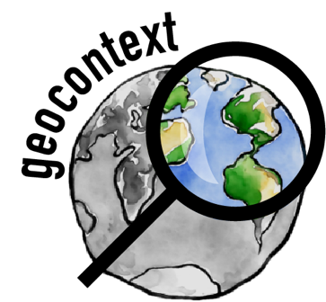

GeoContext:

*A social and political context*

*for geoscience education*

**https://geo-context.github.io**

**Companion Document for “Land Grab Universities”**

**Contributors**: Harriet C.P. Lau

**Keywords**: Native Americans, reparations, American Expansion, Colonialism, Higher Education

**Location**: United States

**People**: n/a

**Last updated**: December 6, 2020

This companion guide accompanies the slides for “Land Grab Universities.” Where applicable, we provide additional context for content shown. We also provide suggestions for questions that can serve as class discussion prompts.

**General Background Reading**

All of the content (text and images) in the slides were taken from <https://www.landgrabu.org/>

Podcasts with the original researchers for further background: <https://www.youtube.com/watch?v=wnlq37ncGxE>

The website provides a thorough narrative of the subject matter with very professional graphics and user-friendly resources.

**Additional Context for Slides**

***Slide 7* |** Suggested activity would be to explore the land that may have been “grabbed” for the benefit of the institution you are teaching at. The slides are currently set to University of California.

<https://www.landgrabu.org/lands>

**Discussion Ideas**

How have you benefited personally from attending this university?

What would be the best way to acknowledge the origins of much of our educational spaces?

Are reparations for native tribes something that needs to be discussed more openly and with a higher profile?